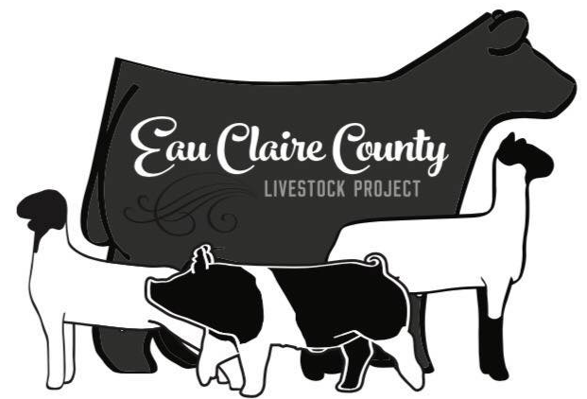
Eau Claire County Livestock Project
EXTRA HOG, SHEEP, & GOAT RELEASE FORM

Exhibitors MUST confirm where their extra hog, sheep, and goats will be going after the fair. This MUST be confirmed by July 1. If you do not turn in this form by July 1st, you CANNOT bring or exhibit your extra hog, sheep, or goat at the fair. The exhibitor must choose between one of the 2 processing plants listed below to take the animal for slaughter. The name of the processing facility MUST be completed by the exhibitor on the form below and confirmed with acceptance by the processing plant. The trucking fees are $20 for any additional Hogs, Sheep, or Goats that will be shipped directly to the business listed below after the Eau Claire County Fair.

Exhibitors are asked not to bring hogs that will not make weight. They will not be allowed to return home after coming to the fairgrounds and will need to go to slaughter. Extra hogs will NOT be allowed to go home. Designated carriers approved by the Livestock Committee will transport ALL swine. Exhibitors will NOT be allowed to transport any of the swine exhibits after the fair due to being a terminal fair.

The Eau Claire County Livestock Project and Eau Claire County Friends of the Fair, or any member of the fair staff will not be responsible for any illness or loss of animals while the project animal is at the fair.

I understand the responsibility for participating in the Eau Claire County Livestock Project and exhibiting at the Eau Claire County Fair with my swine, sheep, and goat project(s). We will also be REQUIRING that information be given to the committee concerning the processing of the extra animals. The Extra Hog, Sheep, & Goat Contact Form will be collected at check-in at the Fair. It is information of who will determine the processing of the extra hog. It is not the responsibility of the committee to contact the owner of the extra animal to determine butchering decisions. Please be prepared to give this information!

Please Circle One: Falls Meats or Off the Rails Meats

By signing below, I confirm that I have spoken to someone at the locker mentioned above, and they have agreed to take our animal.

Circle which species: Hog, Sheep, or Goat

Exhibitor: _____________________________________________
Parent: _______________________________________________
Date: _________________________________________________

**Please fill out one sheet per animal**

Extra Hog, Sheep, & Goat Form and $20 per animal MUST be on file with the
Eau Claire County Livestock Secretary before July 1, 2025.
Please mail to PO Box 434, Augusta, WI 54722.

