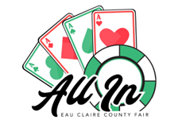
Eau Claire County Friends of the Fair
PO Box 434
Augusta, WI 54722
eauclairefair@gmail.com
715-456-6119
December 31, 2025

I hope this letter finds you well as we begin a new year full of opportunity and community growth. I am writing to share our enthusiasm for the upcoming 2026 Eau Claire County Fair, taking place July 24–27, 2026, and to submit our donation packet for your consideration.
As a proud supporter of local youth and community events, we believe the County Fair is a vital opportunity to celebrate agriculture, education, and the hardworking individuals who strengthen our vibrant community. This letter is being sent early to help businesses plan for their annual budgets and to ensure ample time to consider sponsorship opportunities.
We are thrilled to introduce several new and exciting events for the 2026 Fair, which we believe will greatly enrich the experience for families, exhibitors, and visitors alike. Your support is instrumental in making these improvements possible. Please see the attached sponsorship packet for the many opportunities available. Together, we can continue upholding the Fair’s mission of nurturing community spirit and creating memorable experiences for all attendees.
We look forward to the possibility of partnering with you to elevate this year’s Fair. Your involvement not only enhances the event but also provides a meaningful platform to showcase your brand to thousands of fairgoers.
Thank you for considering support of the Eau Claire County Fair. If you have any questions or need further information, please feel free to reach out. We would appreciate hearing from you by April 1, 2026, so we can discuss these opportunities further.
Warm regards,
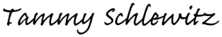

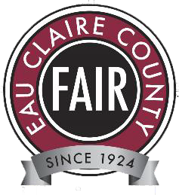
Tammy Schlewitz
eauclairefair@gmail.com
Eau Claire County Friends of the Fair – Fair Coordinator 715-456-6119

Friends of the Fair Packages

SUPREME GRAND CHAMPION PACKAGE - $7,500
- Theme Day Sponsor - naming rights for Thursday, Friday, or Saturday –
- name and logo recognition at gates, website, and official Fair schedule
- 10x10 booth space outside the Expo Center
- Recognition on official Fair schedule
- Link to company website on the Sponsor page of eauclairecountyfair.com
- Special call out on Eau Claire County Fair’s social media pages

GRAND CHAMPION PACKAGE - $5,000
- Gate Signage - listed on signage on each entrance gate
- 10x10 booth space outside the Expo Center
- Recognition on official Fair schedule
- Link to company website on the Sponsor page of eauclairecountyfair.com
- Special call out on Eau Clarie County Fair’s social media pages

CHAMPION PACKAGE - $2,500
- Recognition on official Fair schedule
- Link to company website on the Sponsor page of eauclairecountyfair.com
- Special call out on Eau Clarie Fair’s social media pages

BLUE RIBBON PACKAGE - $1,000
- Link to company website on the Sponsor page of eauclairecountyfair.com
- Special call out on Eau Claire County Fair’s social media pages

RED RIBBON PACKAGE - $500
- Listing on the Sponsor page of eauclairecountyfair.com

WHITE RIBBON PACKAGE - $250
- Listing on the Sponsor page of eauclairecountyfair.com

FAIR SUPPORTER - DONATE ANY AMOUNT TO THE FAIR
Fair Supporter gifts to the Eau Claire County Fair are general Fair funding donations. They help to provide the infrastructure needed to advance the Eau Claire County Fair vision and sustain the Fair for years to come. Investments in the Fair make a real difference by helping expand opportunities and offerings for our youth exhibitors and community. Fair Supporters recognized on the Fair website.
The Fair Supporter general fund assists:
- youth awards – Trophy sponsors $
- the recruitment and retention of judges, chairs, superintendents, volunteers, and staff;
- hands-on learning experiences from our Kids Tent to Theme Days events;
- community partnerships to increase youth involvement;
- daily entertainment, community acts, and music offerings; and
- youth project displays, livestock showrings, and overall event costs
There is strength in numbers, and the cumulative power of gifts helps our youth achieve lifelong skills.

Rodeo Sponsors

Presenting Sponsor - $7,500
- Presenting level naming rights (Eau Claire County Bulls and Barrels presented by )
- Recognition on Rodeo Advertising
- Outgate Arena Banner
- Link to company website on the Sponsor page of eauclairecountyfair.com
- Special shout out during the Rodeo

Chute Sponsor - $5,000
- Second tier banner placement on bucking chutes
- Link to company website on the Sponsor page of eauclairecountyfair.com
- Special call out on Eau Clarie County Fair’s social media

Rodeo Arena Sponsor - $2,500
- Bleachers Signage - listed on signage on each set of bleachers
- Link to company website on the Sponsor page of eauclairecountyfair.com
- Special call out on Eau Clarie Fair’s social media pages

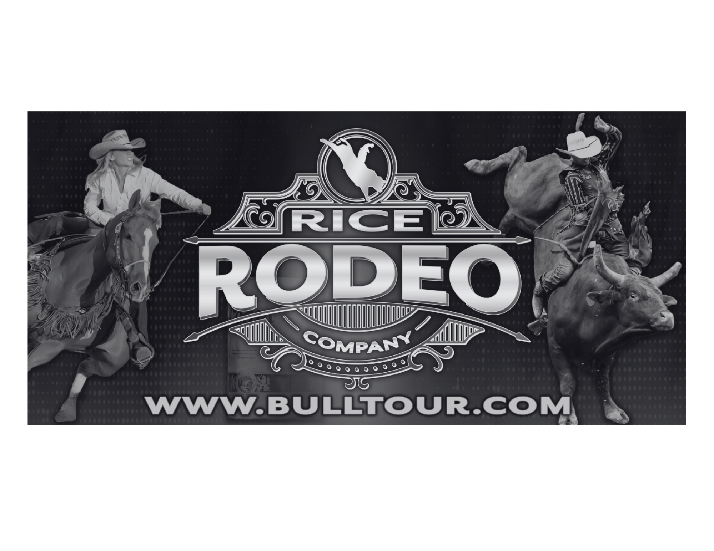
Buckle Sponsor- $1,500
- Link to company website on the Sponsor page of eauclairecountyfair.com
- Special call out on Eau Claire County Fair’s social media pages

Cowboy Hat Sponsor- $500
- Listing on the Sponsor page of eauclairecountyfair.com

Individual Sponsorship Offerings

Expo center naming Rights - $2,500 (1 available)
Sponsor the Expo Center for the week of the Fair. The Expo Center will showcase youth exhibits and judging events, a daily food stand, a coloring activity, and the fair office. As a sponsor, your company logo will be displayed on a banner outside the building. You will also receive recognition on the fair’s website, and promotion in various fair materials, including the event schedule.

Tents - $2,500 (3 available)
When you sponsor the Main Stage Tent, your brand will be in the spotlight. Your company logo will be prominently displayed on a banner outside the Main Stage Tent, and you'll receive recognition during performances and events, listing on the website and in the schedule, and promotion on the Fair's social media channels. Two Show Tents are available for sponsorship, including the Beef & Dairy Tent and the Swine, Sheep, & Goat Tent, which also hosts the Livestock Auction. Sponsors will be announced during shows, listed on the website and schedules, and promoted on the fair's social media, ensuring your brand's visibility and recognition.

Barn Naming Rights - $2,500 (3 available)
Sponsor the 1. Swine, Sheep, and Goat, 2. Beef and Dairy, or 3. Poultry & Rabbit Barn for the week of the Fair. Sponsor will have their company logo on a banner outside the building along with recognition by the judges during the shows, listing on the website, on the schedule, and promotion on the Social Media Channels.
Kids Day - $500 (multiple available)
One of the most popular attractions at the fair is Kids Day. It's a unique opportunity for many kids to get hands-on experience with real farm animals. Your support is crucial in keeping this area thriving. We're committed to bringing back a petting zoo and expanding this area to be even more exciting, truly bringing agriculture to these young minds. As a sponsor, your contribution will be acknowledged with your name added to the Kids Day sponsor board, and listed on the website and in all promotional materials, highlighting the significant role you play in making this day a success.

Showring Banner Placement - $250 (Multiple available)
Get your name and logo in a high visibility area by sponsoring your 3’x8’ banner in the Swine, Sheep & Goat, Beef & Dairy, or Dog showrings. Each Sponsor receives a listing on the Fair website and on the schedule. Please list the showring preferred on the sponsorship form. Sponsor MUST drop off their banner(s) at the Fair on Monday July 20, 2026 – contact the Fair Coordinator Tammy Schlewitz at 715-456-6119 or eauclairefair@gmail.com to make arrangements.

Website Listing - $250 (multiple available)
Want exposure to thousands of attendees, exhibitors, and partners of the Fair? List your company’s logo with a link to your website on the sponsor page on the Fair’s website. Listings will be published on the website until December 31 of the current Fair year.
Pedal Tractor Pull Sponsor ($1,000)
As the official sponsor of the Pedal Tractor Pull, your support helps bring this popular, family-friendly attraction to life at the Eau Claire County Fair. In addition to all benefits received by our Blue Ribbon Package, Pedal Tractor Pull Sponsors enjoy enhanced recognition throughout the event. This includes prominent signage displayed at the Pedal Tractor Pull area and at fairground entrances, along with a designated space to meet and engage with participants and spectators.
Eau Claire County Friends of the Fair 2026 Sponsorship Form

Thank you for your generous support of the Eau Claire County Fair! Please fill out the form below and return it with payment to Eau Claire County Friends of the Fair - P.O. Box 434, Augusta, WI 54722. The Eau Claire County Fair is a 501c3 organization.

If you are interested in a customized package or have a question on a specific package or offering, please contact Heather Erdman (715-577-5366) or Tammy Schlewitz (715-456-6119) at eauclairefair@gmail.com.

Company:

Name:

Address:

City: State: Zip Code:

Phone: Email:

Company website: Facebook:

Sponsorship package/Offering:

Requested area/award:

Total Amount: $
(Make check payable to: Eau Claire County Friends of the Fair)
Company Name to be used for website/signage listing:

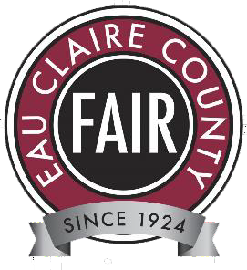
Please send logos to eauclairefair@gmail.com Donations are requested by April 1, 2026.

